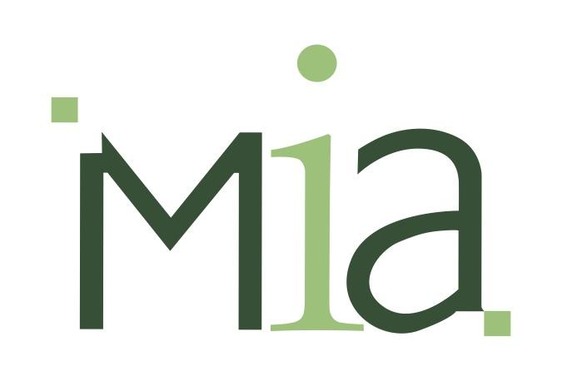
Press release no. 11/2018

EIMA M.i.A. Salone, the EIMA International multifunctional area

This exhibition area is dedicated to work on defending the land, conservation of the environment and qualifications for the production of food crops to present a unique sector in the Bologna exposition. Also planned are theme courses and entertainment initiatives.

EIMA M.i.A. is a specialized salon promoted by FederUnacoma, the National Federation of Agricultural Machinery Manufacturers, in the setting of EIMA International 2018, the International Exposition of Machinery for Agriculture and Gardening coming up in the Bologna trade fair from November 7 to 11. The venue is Pavilion 18 II directly across from the fair’s North entrance with a route for the contents of multifunctional agriculture.
The salon includes machinery and systems for agricultural tourism and recreation, for maintenance work on the land and urban greenery, for agro-industry productions on a small scale set up in an especially scenographic surroundings with impressive architecture and the green culture. A purpose of the arrangements is to invite visitors to a metropolitan route leading to City-Countryside and Return. The M.i.A. sectors are identified by the use of four colors along the route. A chronicle of hydro-geographic damage runs along the point of departure identified by a Blue line at the Pavilion entrance. The Green color in the passage is associated with sustainable Biodiversity and Yellow is dominant for the issue of the maintenance of urban and suburban agriculture and the conservation of the cultural aspects of the countryside. The White area is focused on consumers and producers intent on the quality and safety of Italian food and organic food products.
Events and roundtables in the Conference Area cover various themes on data from institutional sources to be reported by the BioHabitat Foundation with displays along a 22 meter section of a wall. The exhibitors are Herambiente, Bottos, Tecnoacque, LaRosa, Terzarossa, Nano Tech Surface, Zucchetti and foundation partners, Ass.O.cert.bio, Accademia di Belle Arti di Bologna, Adi, Camera di Commercio di Bologna. This stretch is intended to give thought to new technologies and European strategies for safeguarding the land and the quality of production environments.
Space has also been set aside for educational play such as the Monitor Quiz for evaluating knowledge of the multifunctional issues and the evening 8, 9 and 10 game with a trial for the Cervellone team. Remaining in the M.i.A. area can lead to an occasion for trying the Green Lounge organic restaurant, another new feature of the 2018 edition.

Rome, October 30, 2018

